JewelBug_Draft is always top line

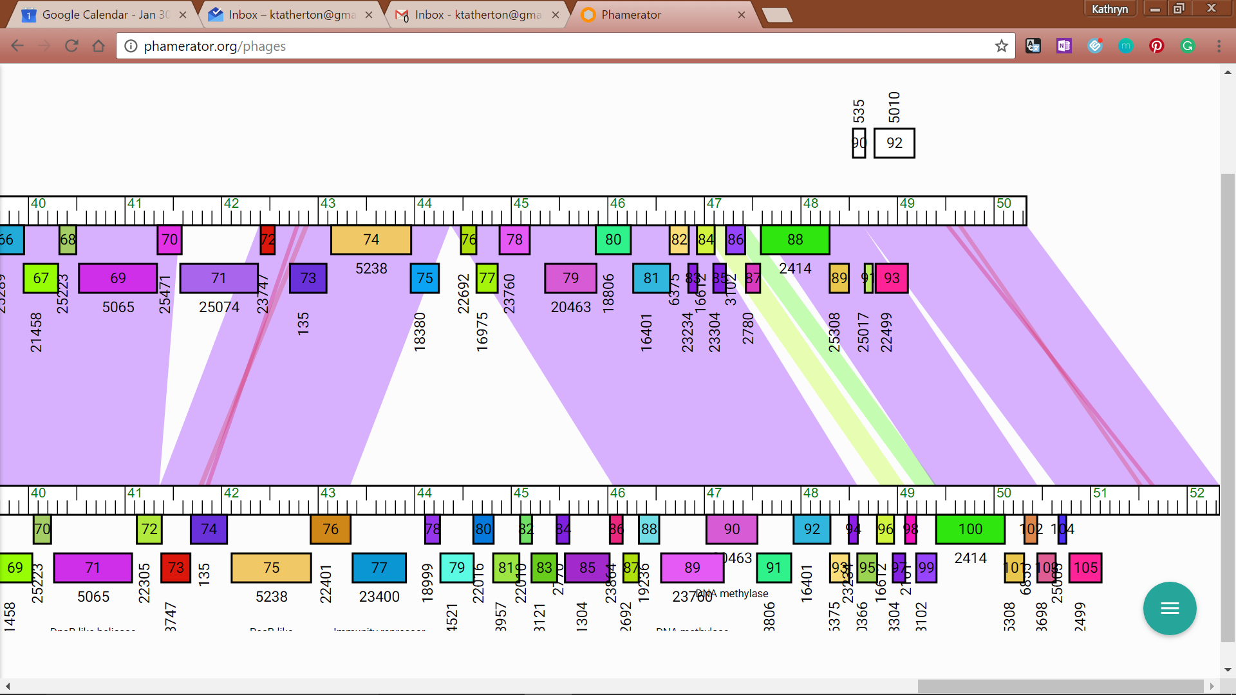

Jewelbug_Draft / Artemis2UCLA

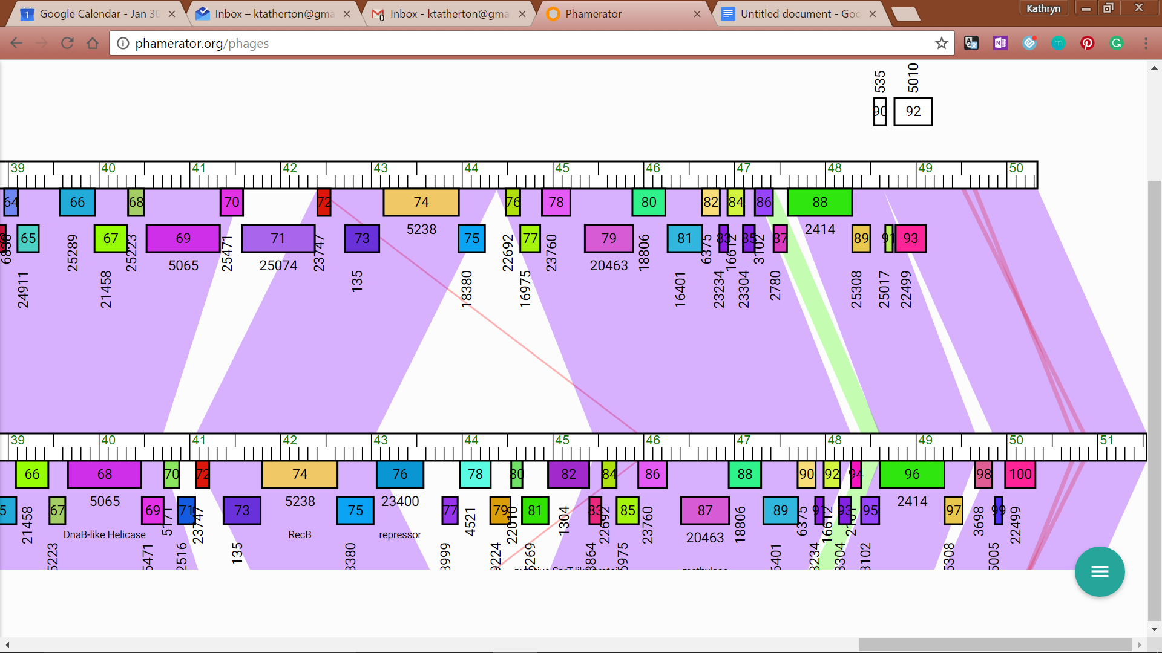Jewelbug_Draft / DaVinci

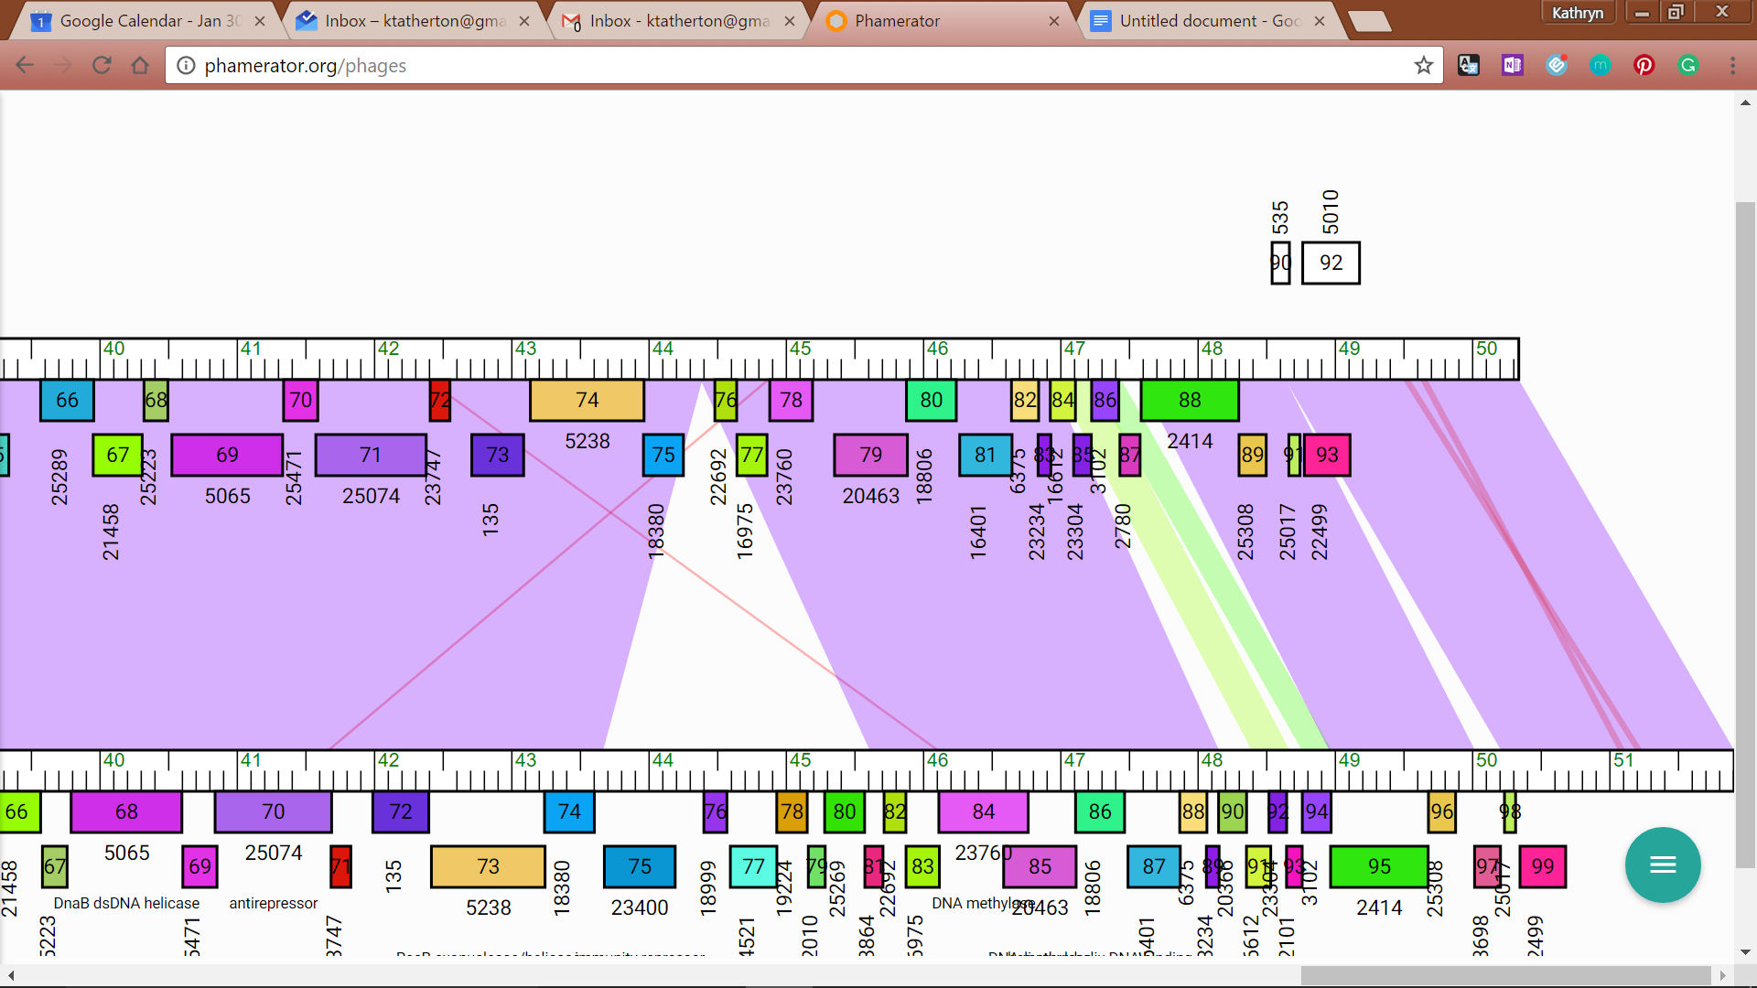Jewelbug_Draft / Isiphiwo

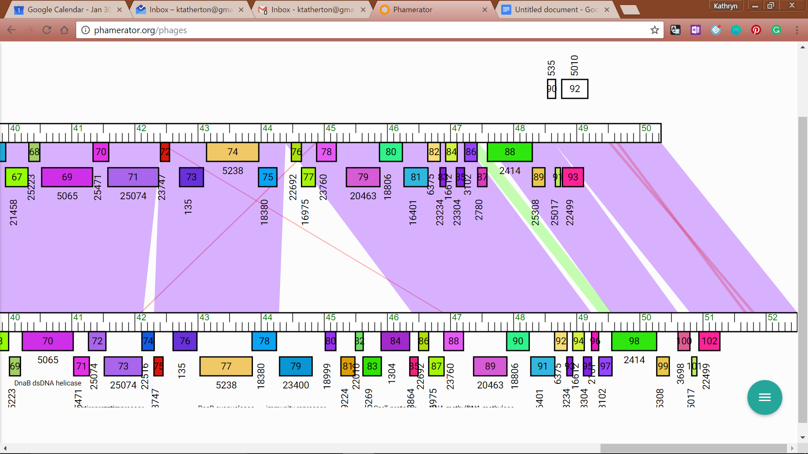

Jewelbug_Draft / McFly

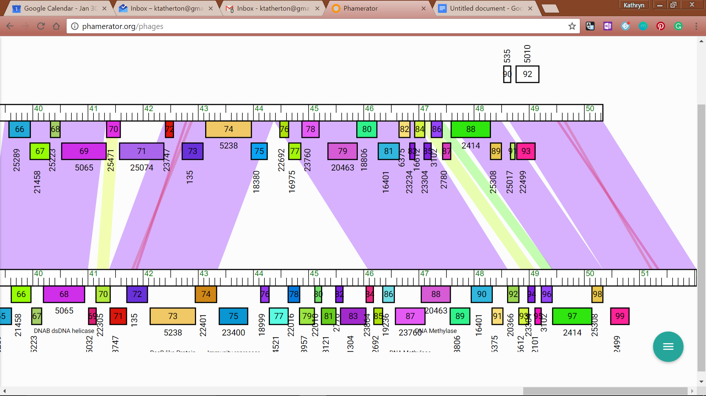

JewelBug_Draft/ToneTone



JewelBug_Draft/Blue7

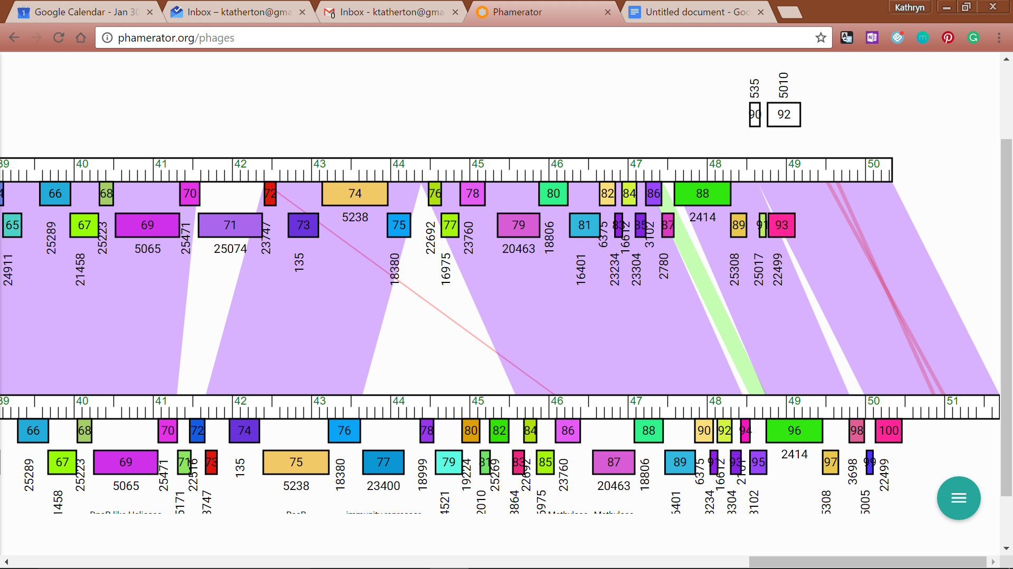

JewelBug_Draft/EricB

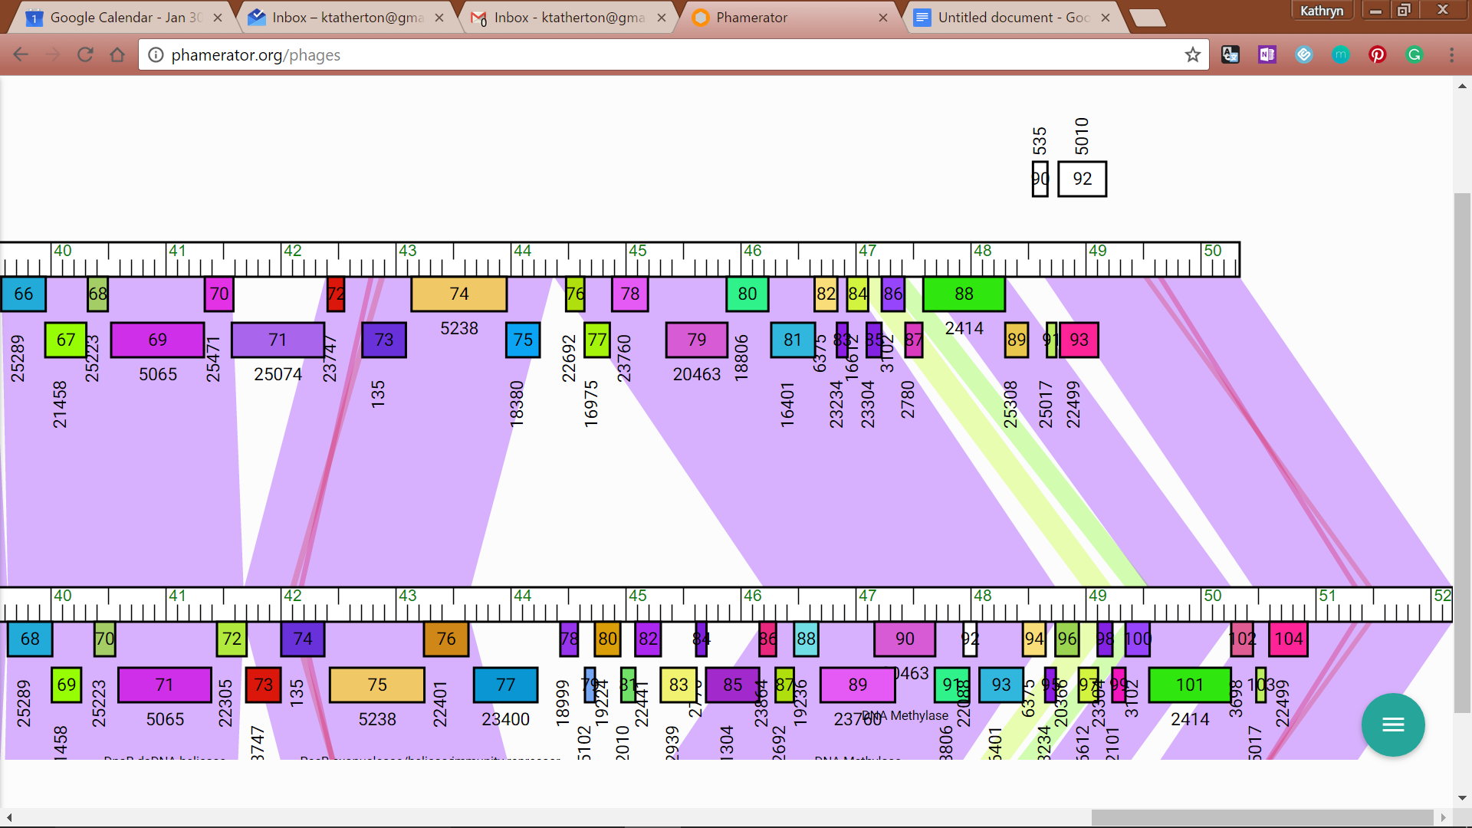

JewelBug_Draft/Gruunaga

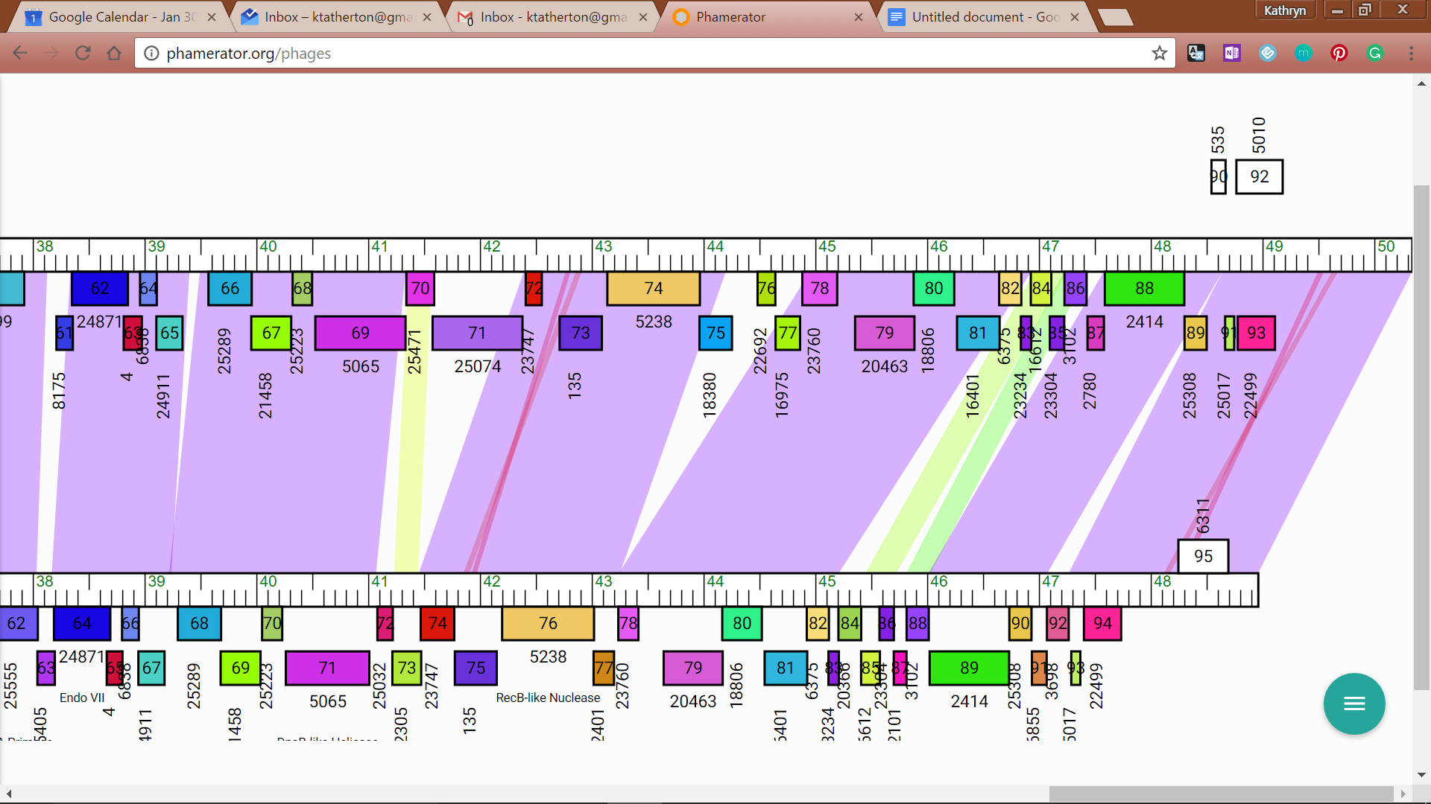

JewelBug_Draft/Jeffabunny

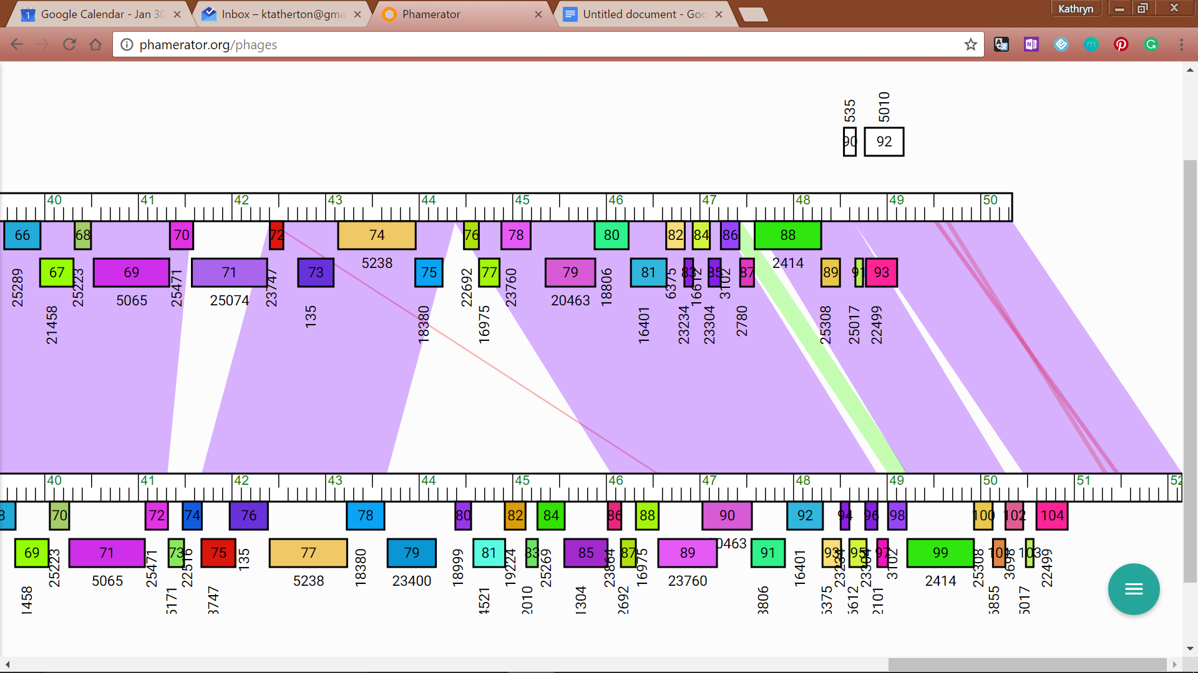

JewelBug_Draft/Kazan

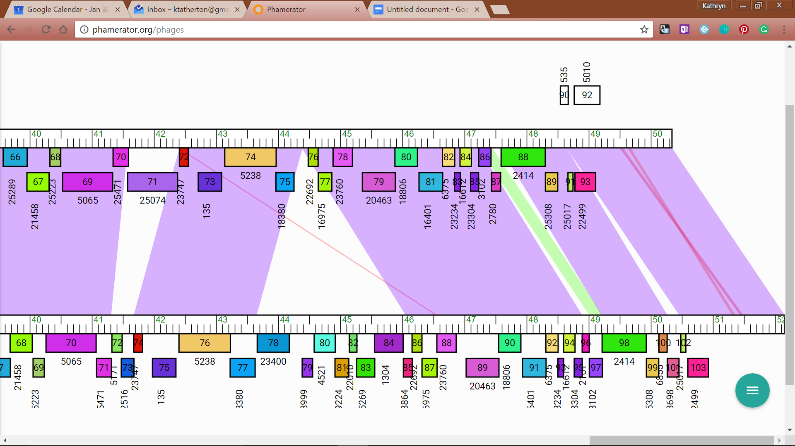

JewelBug_Draft/VohminGhazi

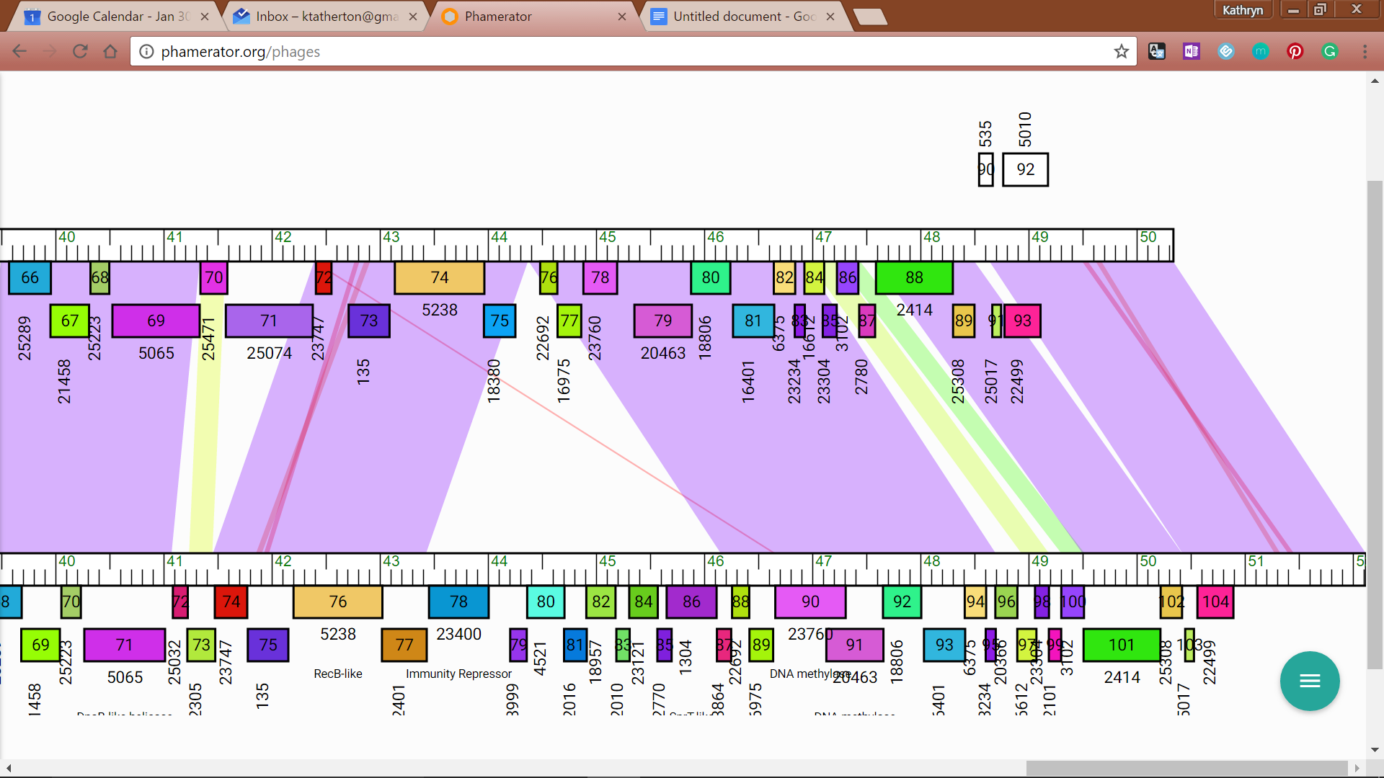

JewelBug_Draft/Zaka

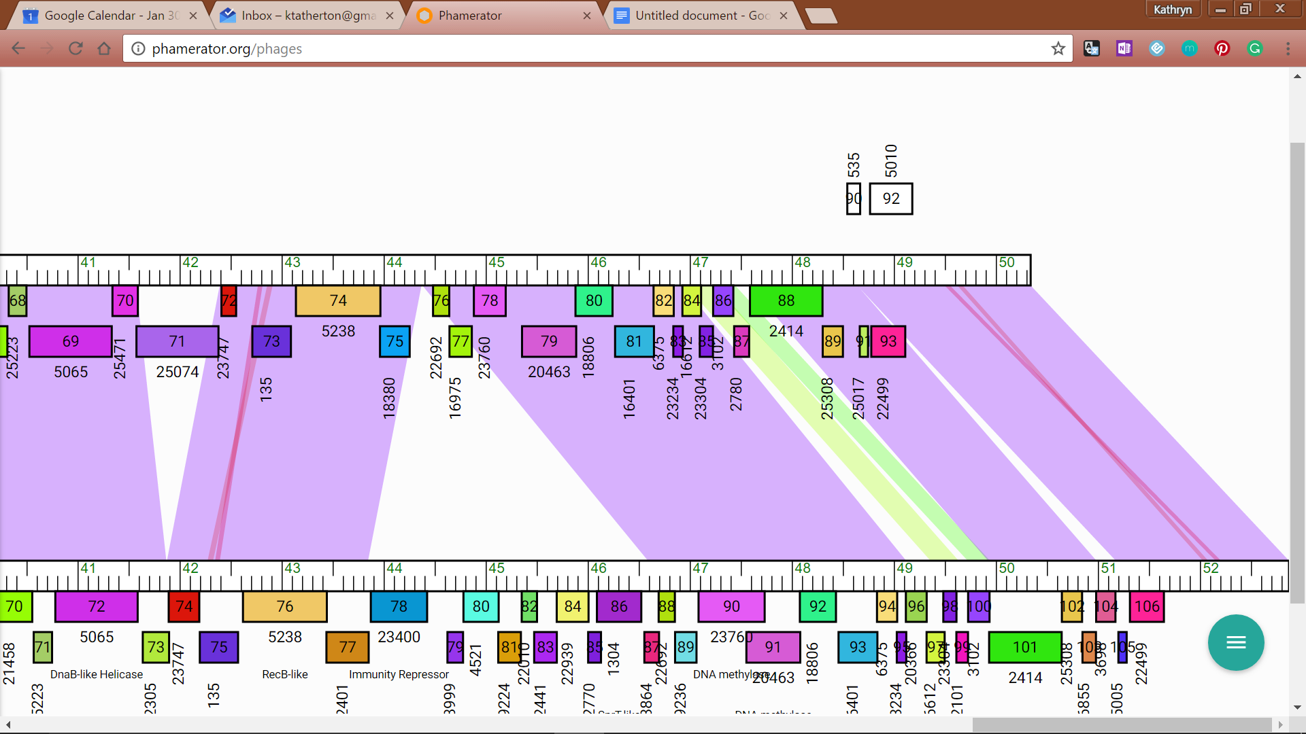

JewelBug_Draft/CloudWang3

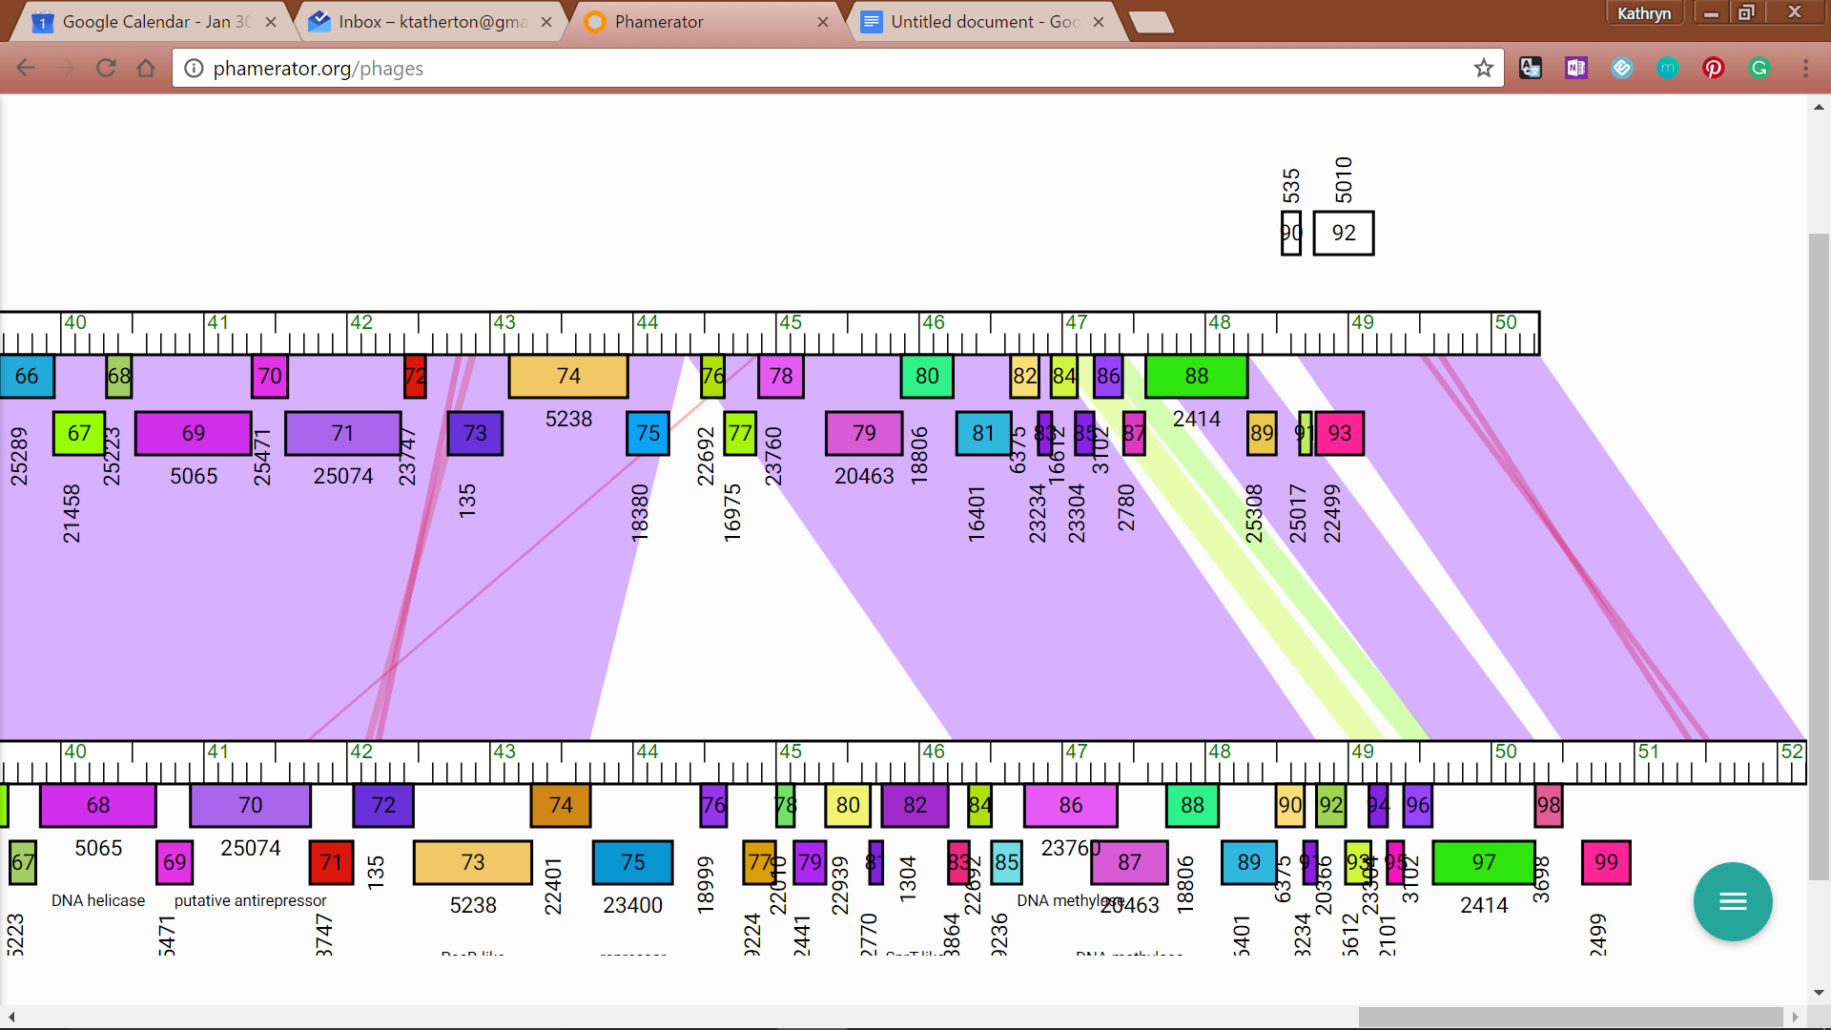

JewelBug_Draft/Gladiator

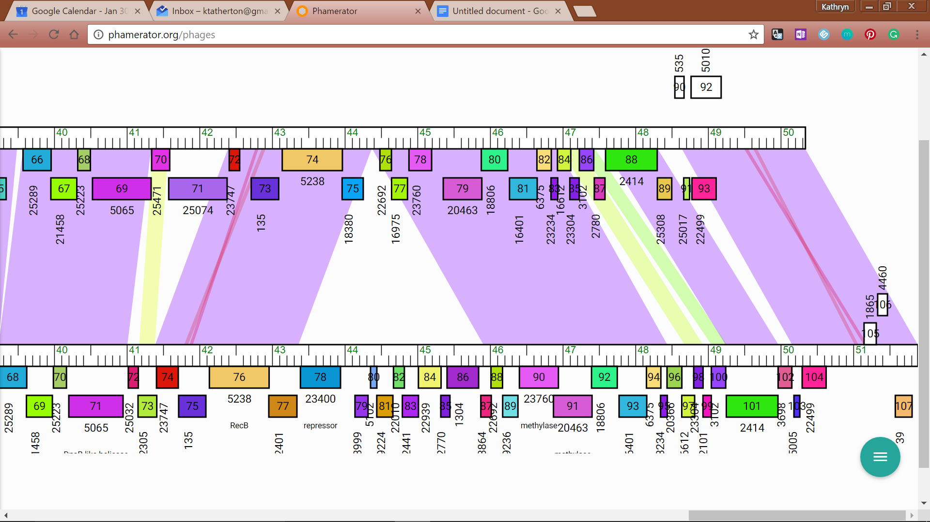

JewelBug_Draft/Hammer